Supply Chain Visibility System
with
Optimization Analytics

POWER BI DASHBOARD SCREENSHOTS
Milestones 1-4|Project Output

Milestone 1-Inventory Turnover Dashboard
Output Screenshot
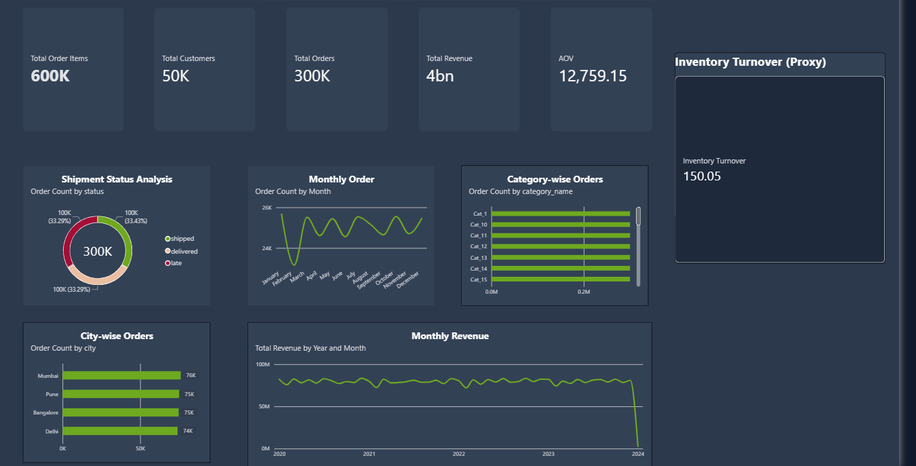

Milsetone 2- Inventory & Delivery Performance Analytics
Output Screenshot
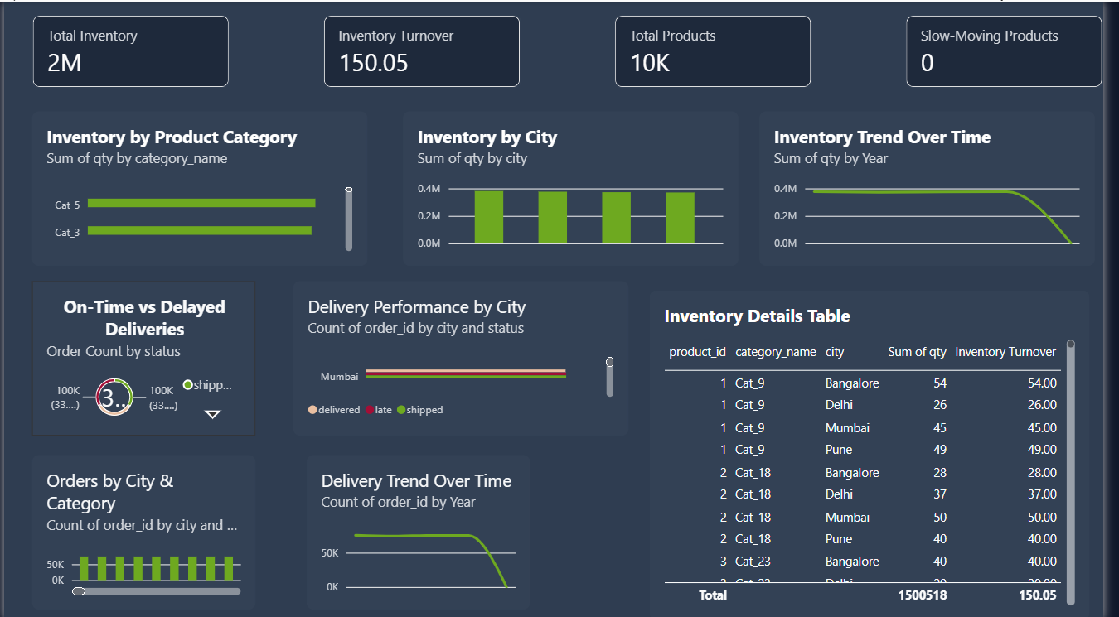

Milestone 3 – Transportation & Supplier Performance Analytics
Output Scerrnshot
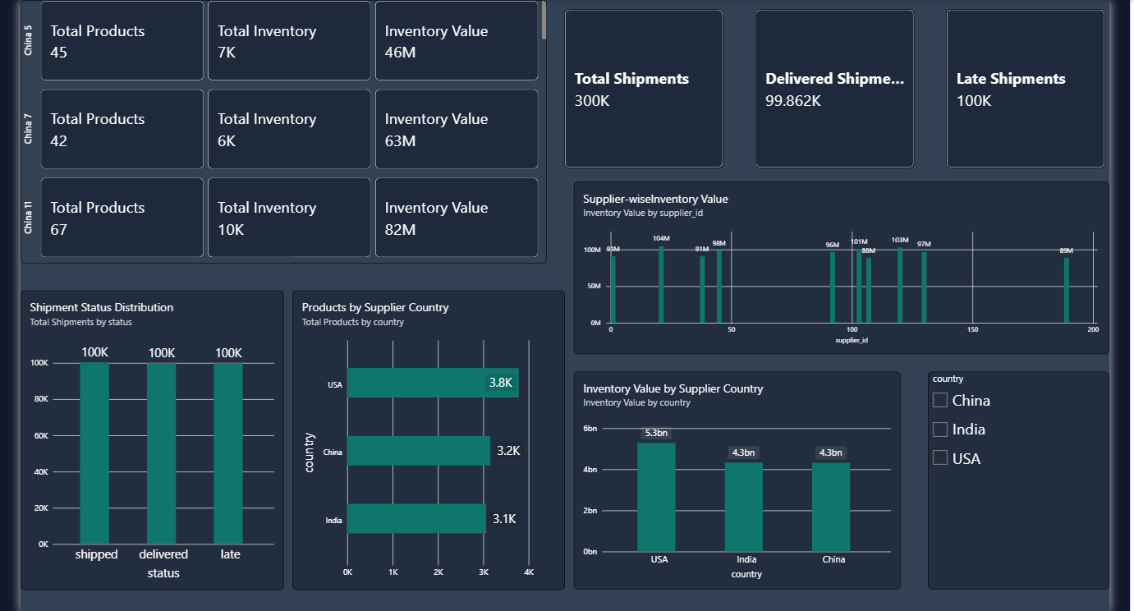

Milestone 4 – Executive Dashboard
Output Screenshots
